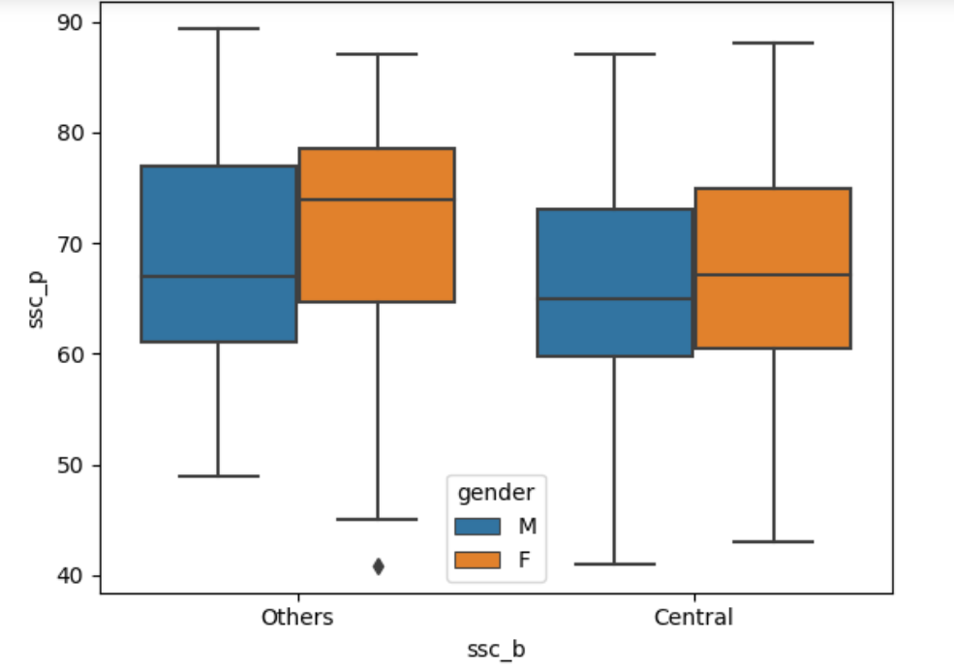

**SSC - OTHER BOARD ANALYSIS**

* In this graph,we are going to compare ssc marks of male and female with other board. Here, starting range of other boards male marks starting from 50,and female marks from 45,comparatively male students got initial marks higher than females.
* And maximum range of male students from 60 to 78 and female from 65 to 79, here female range higher than male.High marks scored from other board male is 90 and female is 88
* Male students Starting range and high marks are scored higher than female,but female students maximum range scored higher than male

**SSC- CENTRAL BOARD ANALYSIS**

* In this graph,we are going to compare ssc marks of male and female of central board.Here, starting range of other boards male marks starting from 40 ,and female marks from 42,comparatively female students got initial marks higher than male students.
* And maximum range of male students from 58 to 75 and female from 61 to 77, here female range higher than male .High marks scored from other board female is 89 and male is 88
* Female students Starting range and high marks are scored higher than male ,but female students maximum range scored higher than male
* In this discussion both boards maximum range comparision ,female students got their high in maximum marks
* High initial marks and high marks are scored by male students in other board and female in central board.